Disability Matters Bendigo!

What: An information session about the free support available for the Bendigo community to contribute to the Disability Royal Commission.
Who: People with disability, friends, family, carers, advocates and supporters
When: Friday 9th September at 12:00-1:30PM
Where: Strathdale Community Centre Hall, 155 Crook Street, Strathdale, 3550 (See Google Maps for location/ Bendigo City website for venue contact details)
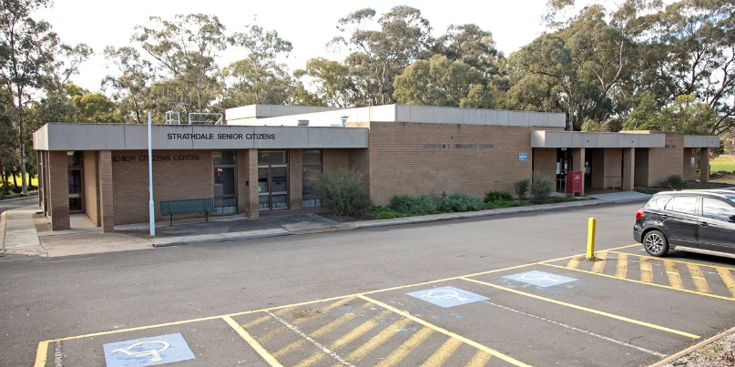
Venue: Strathdale Community Centre – Image from ‘Let’s talk greater Bendigo’ website.

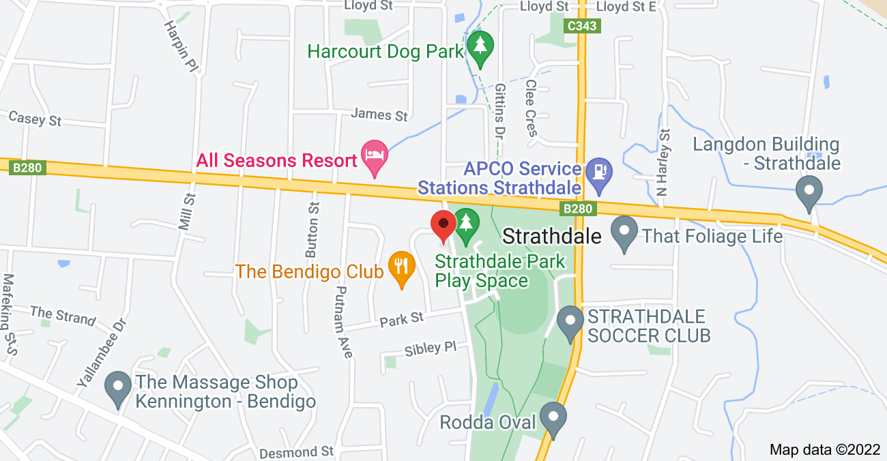

Google Maps venue location: 155 Crook Street, Strathdale, Vic, 3550

Accessibility
- Ramp access
- Double door access into all areas of the building
- Good internal lighting
- Wheelchair access to bathrooms
- Gravel surface outside of building
- The surface of the hall where the event will take place will be wooden floorboards
- The foyer in which you enter to get through to the hall has a carpeted surface
- There will be a quiet/chill out room opposite the hall accessible throughout the duration of the event.
- The foyer has couches and kitchen amenities for people who would like to have some quiet time and make themselves a cup of tea
- Hall size: 15.5 metres x 23 metres, accommodates approx. 300 people
- The area is surround by parklands if you need to get some fresh air during the event, along with picnic and barbecue areas
- There is play equipment outside the venue for those who are bringing children to the event

Please let us know of any other accessibility and dietary requirements when you register to get your ticket.

Transport
- Onsite parking
- Bus stop (Bus no.60, Stops at: Putnam Ave/McIvor Hwy) located on McIvor Highway, a 6-minute walk (according to Google maps) from the venue location.
- Dedicated accessible parking directly in front of the building
- Enter venue via Crook St
- If catching the train to Bendigo station it is a 25-minute bus ride from the station (Bus no. 60), and a 6-minute walk from the bus stop (Putnam Ave/McIvor Hwy) to the venue.

Event details
The Disability Royal Commission is investigating the mistreatment of people with disability and wants to hear from people with:
- lived experience of disability
- their family members
- friends
- carers
- advocates
- supporters

Come along to this information session to find out how you can access free support to share your stories and ideas for making Australia safer and more inclusive of people with disability.

This information session will provide:
- Information about the Disability Royal Commission and the free legal, counselling and advocacy supports available

- Demonstrations on how to share your story and ideas for change with the Disability Royal Commission

- Access to onsite support staff to answer your questions about the Disability Royal Commission

- Support to book follow up appointments for free legal, advocacy and counselling support

There will be a short PowerPoint presentation and a role play to follow, which will explain how to access support services. We will have questions after the role play and a light lunch.

Contact details
For more information, contact Your Story Legal Support on 1800 77 1800 (free call) or visit the website: https://yourstorydisabilitylegal.org.au/Contact-us for other ways to get in touch.

Event hosts
This event is hosted by Your Story Disability Legal Support, Relationships Australia Victoria, Rights Information and Advocacy Centre, Drummond Street Services and Leadership Plus. We will have representatives from each organisation joining us for this event.

Acknowledgment of Country

This event will take place on the land of the Dja Dja Wurrung people of the land which now comprises Greater Bendigo. We would like to pay our respects to their Elders past present and emerging.

