Disability Matters Horsham!

What: An information session about the free supports available for the Horsham community to contribute to the Disability Royal Commission.
Who: People with disability, friends, family, carers, advocates, and supporters
When: Thursday 20th October at 12:00-1:30PM
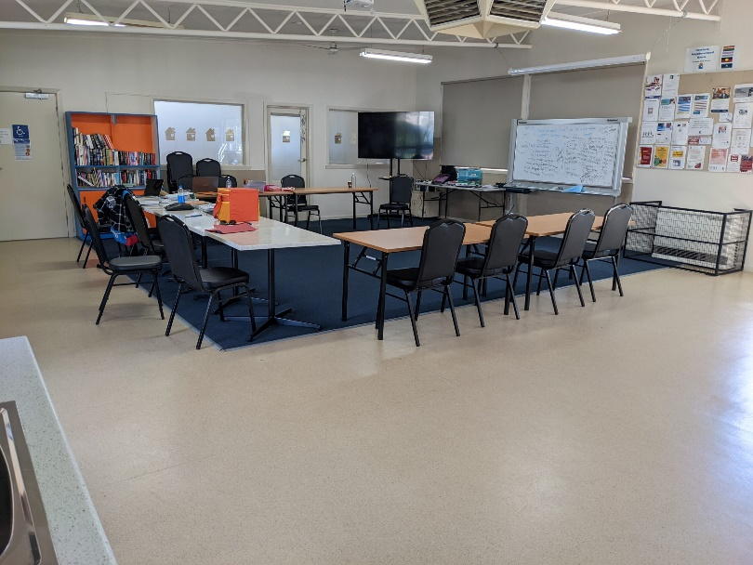
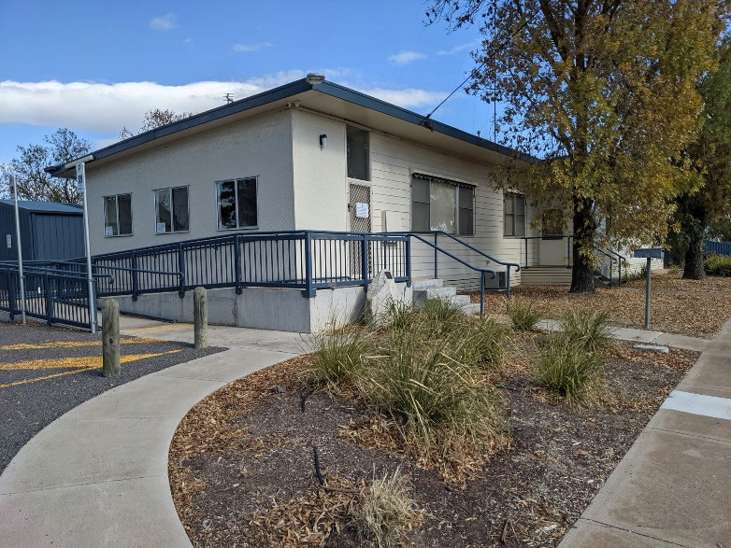
Where: Horsham Neighbourhood House: 13-15 Robin Street, Horsham (See Google Maps for location/ Venue Website for venue details)
Venue. Image obtained from the Horsham Neighbourhood House Facebook Page.
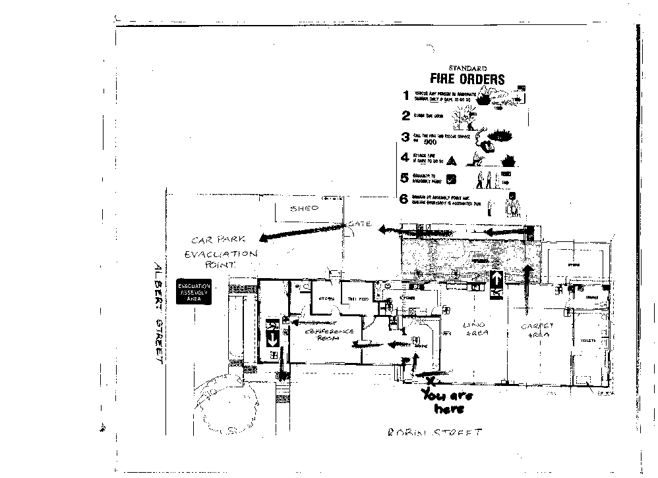
Room that the event will take place in. Image obtained from the Horsham Neighbourhood House Website.
Note: The chairs and tables seen in this image will not be set up like this in this event.

Floor Plan of the event venue. Obtained via staff from Horsham Neighbourhood House.

Accessibility
- Ramp access
Ramp 1: concrete ramp with one door push access
Ramp 2: wooden ramp with two doors push access
- Push doors at front entrance
- Wheelchair access to all rooms/facilities within the venue
- Wheelchair access to bathrooms – bathrooms have railing and a back seat rest
- Written signage throughout building. Toilets have Braille signage.
- All gender labelled bathrooms
- Gravel surface outside of building
- Building carpark has gravel surface. There are 6 parking spots available on-site with 1 allocated accessible parking spot. There is off-site parking available.
- The surface inside the building is a combination of carpet and lino
- There is a quiet room/chill-out room opposite the room of the event, which will be accessible at all times
- Service animals and pets will be allowed into the building
- If you would like to check out the venue prior to the event, we can organise for a staff member from Horsham Neighbourhood House to show you around.

Please let us know of any other accessibility and/or dietary requirements when you register to get your ticket.

Transport
- Limited onsite parking, off-site parking also available
- Closest bus stop is Langlands St/Albert St, (Bus no.1 or 2) a two-minute walk (160 metres) from the event venue as per Google Maps. This stop is located on Albert St.
- 1 dedicated accessible parking spot directly in front of the building
- Closest train station is Horsham Station. It is a 12-minute walk (1km) from the event venue as per Google Maps.

Event details
The Disability Royal Commission is investigating the mistreatment of people with disability and wants to hear from people with:
- lived experience of disability
- their family members
- friends
- carers
- advocates
- supporters

Come along to this information session to find out how you can access free support to share your stories and ideas for making Australia safer and more inclusive of people with disability.

This information session will provide:
- Information about the Disability Royal Commission and the free legal, counselling and advocacy supports available

- Demonstrations on how to share your story and ideas for change with the Disability Royal Commission

- Access to onsite support staff to answer your questions about the Disability Royal Commission

- Support to book follow up appointments for free legal, advocacy and counselling support

There will be a short PowerPoint presentation about each of the services and a case study to follow that will explain how to access support. We will have time for questions after the role play and a light lunch.

Contact details
For more information, contact Your Story Legal Support on 1800 77 1800 (free call) or visit the website: https://yourstorydisabilitylegal.org.au/Contact-us for other ways to get in touch.

Event hosts
This event is hosted by Your Story Disability Legal Support, Drummond Street Services, Relationships Australia Victoria, Rights Information and Advocacy Centre, and Leadership Plus. We will have representatives from each organisation joining us for this event.

Acknowledgment of Country

We would like to acknowledge that this event will take place on the land of the Wotjobaluk, Wergaia, Jupagulk, Jaadwa and Jadawadjali people. We pay our respects to their Elders past, present and emerging.

